2021 - 2022

Child’s Name ______________________________ Date _________________

We are licensed by the state of Virginia; it is MANDATORY that each registration be filled out completely. Please attached the following documents along with the application:

- Birth Certificate

- Physical within the last 12 months

- Immunization Records

- Insurance Card

- Verification of all household income including SSI, disability, food stamps, TANF, pay stubs, unemployment, etc.

Please Note:

Open spots are RARE so WEC works from a waiting list and an administrative staff member will contact you when a spot for your child is available. While one the waiting, if your number changes be sure to update us so you don’t miss our call.

No child will be admitted to the program or placed on a waiting list until all required information is on file at WEC. We also require that the first week be paid in FULL before your child can start.
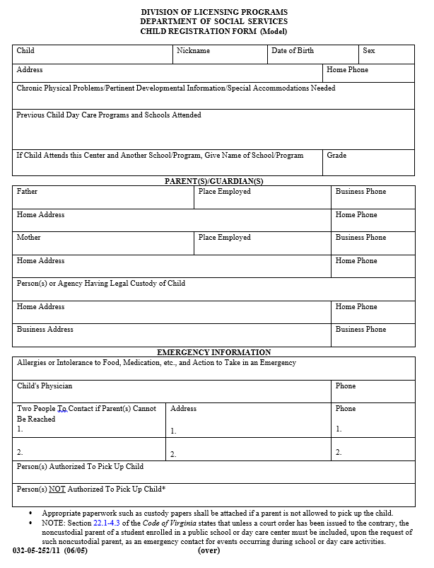
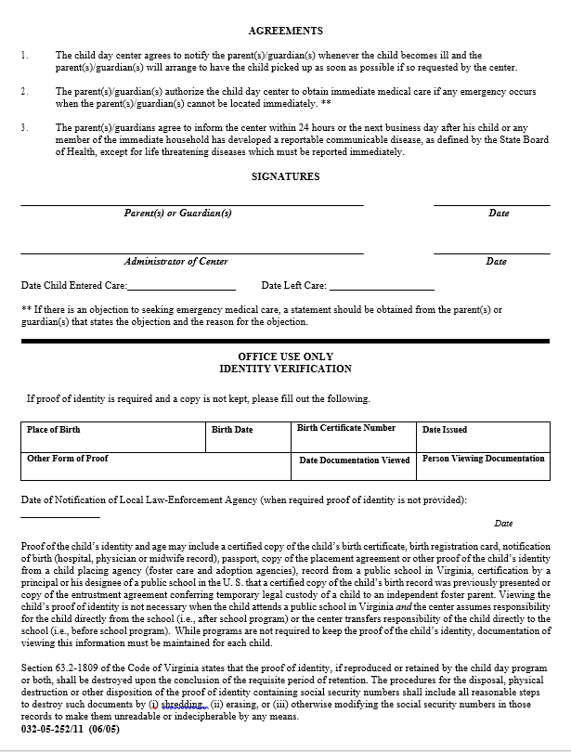
FAMILY INFORMATION

Email_____________________________________________________________________

Marital Status – Circle One: Married Single Separated Divorced Widowed

The following information is confidential and only used for compiling statistics to obtain funding from HUD. No names or individual information will be conveyed to anyone.

Number of people in the household
# Children _________________________ #Adults ____________________

Names and ages of child’s siblings: _________________________________________________

Age of Mother _____________________ Age of Father _________________________

Highest education level achieved by Mother_______________ Father _______________

Do you receive income through any of the following?

TANF _____Yes _____No Amt/month_________________
Food Stamps _____Yes _____No Amt/month_________________
Free/Reduced School Lunch _____Yes _____No
Medicaid _____Yes _____No
SSI for Self or Child _____Yes _____No Amt/month_________________
Disability _____Yes _____No Amt/month_________________
Child Support _____Yes _____No Amt/month_________________
Veterans Benefits _____Yes _____No Amt/month_________________
Housing Assistance _____Yes _____No
Section 8 _____Yes _____No
Public Housing _____Yes _____No
Unemployment _____Yes _____No Amt/month_________________
Habitat Housing _____Yes _____No
Any other form of Assistance _____Yes _____No
Type of Assistance ___________________________ Amt/month_________________

TOTAL ANNUAL INCOME FOR HOUSEHOLD
“Annual Income” estimated for the 12-month period beginning on registration date. Include all sources and amounts of earned and unearned income for all family members counted above excluding one-time sources such as scholarships, death benefits. (Include TANF, Food Stamps, Child Support, SSI, Disability & Veterans Benefits.)

Total Annual Income $ ______________________

I VERIFY THAT ALL THE INFORMATION GIVEN ABOVE IS CORRECT TO THE BEST OF MY KNOWLEDGE.

_______________________________________________ ________________________________
(Parent’s Signature) (Date)

- YOU ARE REQUIRED TO ATTACH YOUR MOST RECENT TAX RETURN OR PROOF OF ALL SOURCES OF INCOME FOR EACH ADULT MEMBER OF THE FAMILY
PERMISSION/AGREEMENTS

HOW WILL YOUR CHILD ARRIVE AND DEPART FROM THE CENTER?
(PLEASE CHECK ALL THAT APPLY)

SCHOOL YEAR SUMMER

ARRIVE DEPART ARRIVE DEPART
Bus _______ Bus _______ Bus _______ Bus _______
Walk ______ Walk _______ Walk ______ Walk ______
Car _______ Car ________ Car _______ Car _______

Please list all individuals who have consent to pick up your child from West End Center. Include their relationship to your child. We will release your child only to persons providing valid identification. Please notify us in writing if you need to add to or delete from the list.

_____________________________________________________ _________________________________________________

_____________________________________________________ _________________________________________________

List all individuals who do not have consent to have contact with your child. A copy of a court order must be kept on file in order to deny a parent contact with a child.
____________________________________ _________________________________

______________________________________________________ _________________________________________________

If you allow your child to walk or to ride the city bus to or from the Center, please sign below assuming full responsibility.

___________________________________________________________ ___________________________
(Parent’s Signature) (Date)

SWIMMING AND SUNSCREEN PERMISSION

_____ I give permission for West End Center staff to offer sunscreen to my child. Staff will
encourage children to wear sunscreen when the UV Index is above 5. Sunscreen will NOT be provided by the Center.

_____ I do not give permission for West End Center staff to offer sunscreen to my child.

__________________________________________ _____________________
(Parent Signature) (Date)

If your child has had any known adverse reactions to sunscreen, please list them below:
___________________________________________________________________________

______ I give my child permission to participate in swimming, wading, and splashing
activities with West End Center.

_____ I do not give my child permission to participate in swimming, wading, and splashing
activities with West End Center.
Please rate your child’s ability to swim:
_____ Non-swimmer _____ Fair swimmer _____ Good swimmer
______________________________________ ___________________________
(Parent Signature) (Date)

USDA FOOD SERVICE PROGRAM

West End Center participates in the USDA Summer Food Service Program operated by the U.S. Department of Agriculture. The Center is committed to offering each child a healthy breakfast, lunch, and snack each day during the summer program and afternoon snack during the school year. In order to best serve your child, it is important that we be aware of any dietary restrictions that may affect your child. Please check any of the situations below that apply to your child.

____ My child has a physical disability and should not be offered the following foods:

PUBLICITY CONSENT FORM

I give permission for my child to be videotaped or photographed for the purpose of promoting the services that West End Center offers.

______________________________________ _________________________
(Parent’s signature) (Date)

PARENTAL AGREEMENT

- West End Center will notify the parent when a child becomes ill.
- The parent will arrange for the child to be picked up as soon as possible when requested by the Center.
- The parent will inform the Center within 24 hours or the next business day after the child or any member of the immediate household has developed any reportable communicable disease, except for life threatening diseases which must be reported immediately.

____________________________________ _____________________
(Parent Signature) (Date)

PARENT CONTRACT

It is very important that we all work together for the well being of your child/children. We ask that you read and agree to abide by the following policies.

I, _______________________________________________, do hereby agree to
(Parent’s name)

- support the Center staff on discipline
- notify the Center of changes in phone numbers, address, emergency contacts, medications, etc.
- drop off and pick up my child/children on time
- notify the Center of changes in my child’s schedule
- notify the Center about my child’s current medication needs
- be considerate about where and how I park my car
- not park in the fenced lot when children are at the Center
- come inside to pick up my child
- notify the Center if my child will be absent
- keep payment of fees current

_______________________________________________ __________________
(Parent’s signature) (Date)

Failure to abide by the above agreement may result in the removal of your child from the
Program.

PARENT HANDBOOK
(can be found on www.westendcenter.org-parent)
I have reviewed a copy of the Parent Handbook, and I agree to be aware of and follow the policies of West End Center. If, at any time, I have a question or concern about a policy, I understand that I am encouraged to schedule an appointment with the Executive Director to discuss my concerns.

I agree to explain to my children and support the rules and policies listed in this form and in the Parent Handbook.

_______________________________________________ __________________
(Parent’s signature) (Date)

CHILD HISTORY

What are your greatest concerns for your child and his/her future?

_____________________________________________________________________________________________________________________

What activities would you like to see your child involved in at the Center?

_____________________________________________________________________________________________________________________

What would you like us to work on with your child?

_____________________________________________________________________________________________________________________

Has your child ever been involved with the court system? __________

If yes, why? __________________________________________________________

Is your child in foster care? __________

Agency ______________________________________________________________

Social Worker _______________________________ Phone _______________

Has your child ever been suspended or expelled from school? _______________________

If yes, why? ____________________________________________________________________

Is your child receiving services, such as counseling, day-treatment, mentoring, in-home services, PT, OT, etc.? (If yes, please state which agency, the service provided, the individual he/she is seeing, and why.)

_____________________________________________________________________________________________________________________

Are you interested in receiving information about any of the services listed in the prior question or any other special services? Please list those you believe your child would benefit from and why.

_____________________________________________________________________________________________________________________

_____________________________________________________________________________________________________________________

Is your child in Special Education (LD, ED, MR), gifted program, or another special program? If yes, please describe.

_____________________________________________________________________________________________________________________

Do you believe your child is learning reading, writing, and other skills as he or she should be?

_____________________________________________________________________________________________________________________

